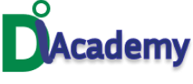It is 31st October 2022 Already!!!!

The year is moving so fast……………

Time waits for no one.

Your tech dreams are still valid.

You can still switch careers.

Do you want to be a Full stack developer?

Are you interested in pursuing a career in data analysis?

Are you worried about making booming sales with Digital marketing?

Oh! You want to secure data in your company.

D I Academy is here to make these dreams of yours valid.

Join our November 2022 Cohort.

It is not too late to register.

Come and Start for Free and register with this link https://tinyurl.com/yz6229um